Fascism
SSWH – 18 Examine the major political and economic factors that shaped world societies between World War I and World War II.
a. Determine the causes and results of the Russian Revolution from the rise of the Bolsheviks under
Lenin to Stalin’s first Five Year Plan.
b. Describe the rise of fascism in Europe and Asia by comparing the policies of Benito Mussolini in Italy,
Adolf Hitler in Germany, and Hirohito in Japan.
c. Describe the nature of totalitarianism and the police state that existed in the Soviet Union, Germany,
and Italy and how they differ from authoritarian governments.
d. Explain the aggression and conflict leading to World War II in Europe and Asia; include the Italian
invasion of Ethiopia, the Spanish Civil War, the Rape of Nanjing in China, and the German violation
of the Treaty of Versailles.

The Authoritarian Response  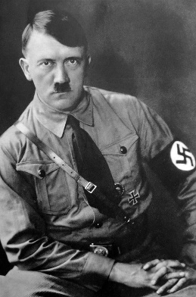  Adolf Hitler was the leader of the Nazi Regime  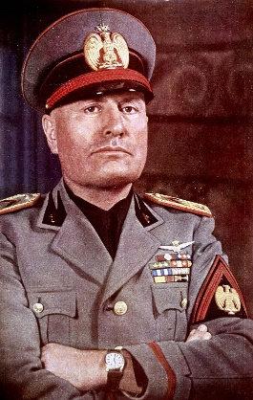  Benito Mussolini  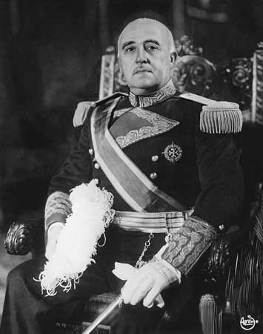  Francisco Franco  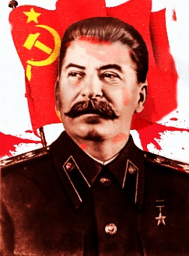  Joseph Stalin | - What led to fascist regimes in Germany?  a.  b.  - What did fascism aim to attack?  a.  b.  c.  - What is another name for the National Socialist Party?  - What is the term for not liking Jews?  - What was the Gestapo?  - What was happening in Spain in 1936?  - Who did the fascist party in Spain back during the Civil War?  - What spread after the Russian Revolution?  a.  b.  - Who led the revolution in Brazil?  - What did Vargas promise the people?  - Who led reforms in Argentina?  - Who led a military coup in Japan?  - Who did Japan went to war with in 1937?  - What areas did Japan control due to imperialism by 1938?  - What did Stalin want to do to Russia?  List the 14 Characteristics of a Fascist regime

