WWI
SSWH – 18 Examine the major political and economic factors that shaped world societies between World War I and World War II.
a. Determine the causes and results of the Russian Revolution from the rise of the Bolsheviks under
Lenin to Stalin’s first Five Year Plan.
b. Describe the rise of fascism in Europe and Asia by comparing the policies of Benito Mussolini in Italy,
Adolf Hitler in Germany, and Hirohito in Japan.
c. Describe the nature of totalitarianism and the police state that existed in the Soviet Union, Germany,
and Italy and how they differ from authoritarian governments.
d. Explain the aggression and conflict leading to World War II in Europe and Asia; include the Italian
invasion of Ethiopia, the Spanish Civil War, the Rape of Nanjing in China, and the German violation
of the Treaty of Versailles.

SSWH – 19 Demonstrate an understanding of the global political, economic, and social impact of World War II.
a. Describe the major conflicts and outcomes, include: North African, Pacific, and European theatres.
b. Identify Nazi ideology and policies that led to the Holocaust and its consequences.
c. Analyze the impact of the military and diplomatic negotiations between the leaders of Great Britain,
the Soviet Union, and the United States.
d. Explain Post-World War II policies and plans for economic recovery, include: the Marshall Plan for
Europe, MacArthur’s plan for Japan, and the formation of the United Nations, NATO, and the
Warsaw Pact

The Coming of the Great War  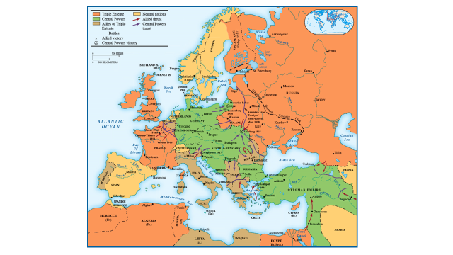  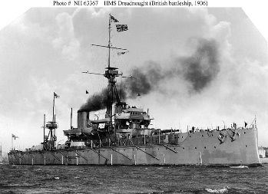  A British Dreadnaught  The order of attack/declaration of WWI  - Austria-Hungary & Germany attack Serbia  - Russia mobilizes to defend Serbia  - Germany declares war on Russia and France  - England declares war on Germany after it invades Belgium  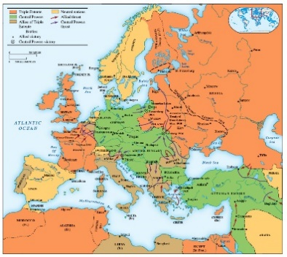  Europe during WWI  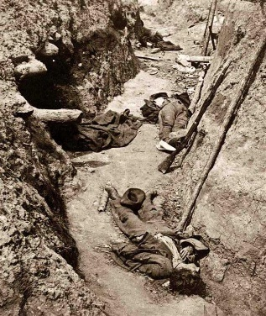  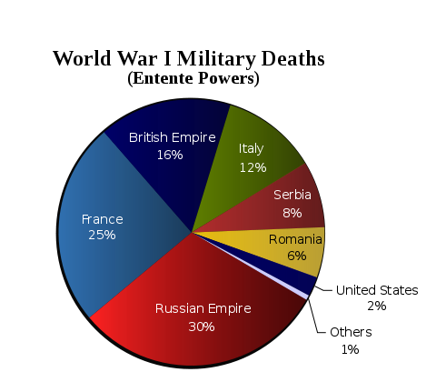  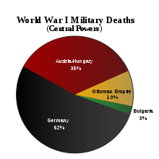 | - What were the causes of WWI?  M  A  I  I  N  - What countries made up the Triple Alliance?  a.  b.  c.  - What countries made up the Triple Entente?  a.  b.  c.  - Who used nationalism and war to unify Germany?  - What event triggered the start of WWI?  - What area was known as the “Power Keg” of the Europe because of nationalistic and imperialistic rivalries?  - What was the “Blank Check” Germany gave to Serbia?  - What happened in August of 1914 that officially started WWI?  - Why was WWI considered an industrial war?  - Give some examples of the new technology used in WWI:  a.  b.  c.  - What is a “front” during war?  - Where did fighting take place on the Eastern Front?  - What type of fighting was used on the Western Front?  - What is a stalemate?  - What were U-Boats?  - What was unrestricted submarine warfare?  - What was significant about the sinking of the Lusitania?  - What were the three main things that pulled the United States into WWI?  a.  b.  c.  - What was the Zimmerman Note/Telegram?  - What is an armistice?  - How much did WWI cost?  - What was the condition that grew out of WWI that led to the rise of to one man rule?  - What did many believe would be used as the basis for the for the Paris Peace Conference?  - What was the League of Nations?  - Why did the Treaty of Versailles fail to keep peace?  a.  b.  c.

