WWII
SSWH – 18 Examine the major political and economic factors that shaped world societies between World War I and World War II.
a. Determine the causes and results of the Russian Revolution from the rise of the Bolsheviks under
Lenin to Stalin’s first Five Year Plan.
b. Describe the rise of fascism in Europe and Asia by comparing the policies of Benito Mussolini in Italy,
Adolf Hitler in Germany, and Hirohito in Japan.
c. Describe the nature of totalitarianism and the police state that existed in the Soviet Union, Germany,
and Italy and how they differ from authoritarian governments.
d. Explain the aggression and conflict leading to World War II in Europe and Asia; include the Italian
invasion of Ethiopia, the Spanish Civil War, the Rape of Nanjing in China, and the German violation
of the Treaty of Versailles.

SSWH – 19 Demonstrate an understanding of the global political, economic, and social impact of World War II.
a. Describe the major conflicts and outcomes, include: North African, Pacific, and European theatres.
b. Identify Nazi ideology and policies that led to the Holocaust and its consequences.
c. Analyze the impact of the military and diplomatic negotiations between the leaders of Great Britain,
the Soviet Union, and the United States.
d. Explain Post-World War II policies and plans for economic recovery, include: the Marshall Plan for
Europe, MacArthur’s plan for Japan, and the formation of the United Nations, NATO, and the
Warsaw Pact

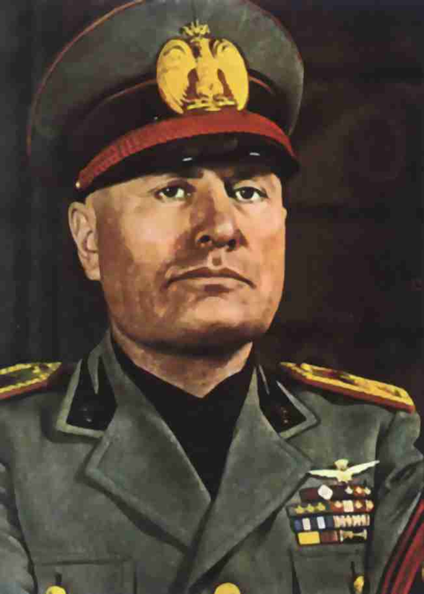  Mussolini  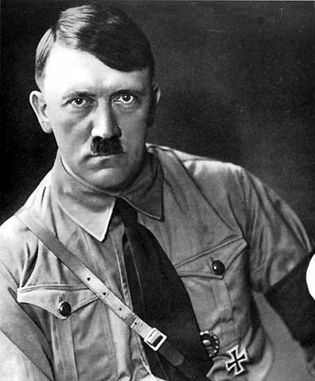  Hitler  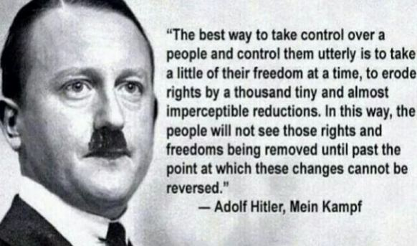  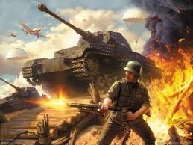  Blitzkrieg  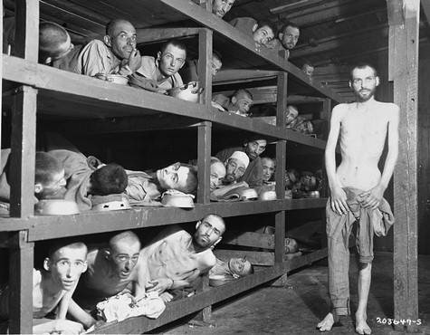  The Holocaust  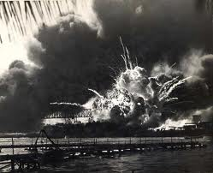  The bombing of Pearl Harbor on Dec. 7, 1941  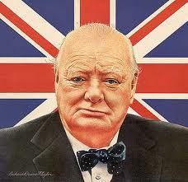  Winston Churchill  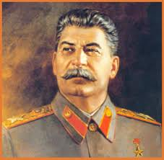  Joseph Stalin  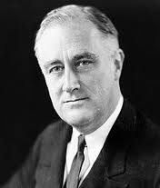  FDR  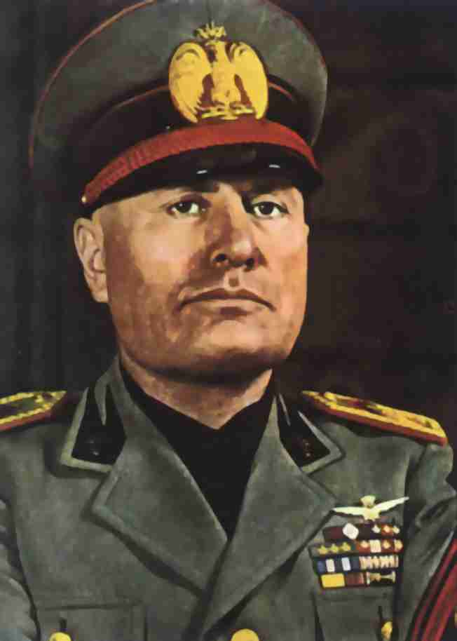  Benito Mussolini  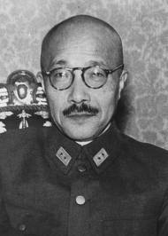  Hideki Tojo  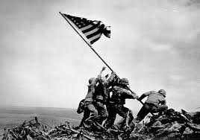  Island Hopping  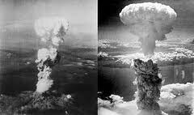 | - In what ways was the League of Nations supposed to keep the peace?  a.  b.  - Why didn’t the United States refuses to join the League of Nations?  - What was the reason that the League of Nations actually keep peace?  - What took place in 1921 that attempted to limit the building of warships, eventually failed because the Japanese ignored it and continued to build warships?  - What was the Locarno Pact?  - Why did the Locarno Pact fail to keep the peace?  - What were the reasons that the Pact of Paris fail?  a.  b.  - What was the Great Depression?  - Who did Hitler and the Germans blame for Germany’s defeat?  - What nations had totalitarian governments during WWII?  a.  b.  c.  d.  - How do totalitarian governments control the people?  a.  b.  c.  - Who was the fascist leader of Italy?  - Who was the fascist leader of Germany?  - What was the Nazi Party?  - What was the book that Hitler wrote while he was in jail?  - What did Mein Kampf outline?  - What was significant about the Enabling Act of 1933?  - What were the Nuremberg Laws?  - What was Kristallnacht?  - Why did the Axis Powers (Italy, Germany, and Japan) seek to expand their empires?  - Hitler claimed he needed land in Europe because the Germans needed Lebensraum, what is Lebensraum?  - What areas did Italy invade/take over?  - What areas did Japan invade/take over?  - What was the policy of appeasement that the British and French took towards Hitler?  - Why did they appease Hitler?  - What country did Hitler sign a non-aggression pact with?  - What country did Germany and Russia divide/split in the pact?  - What event was the start of WWII?  - What was the German blitzkrieg?  - What was Sitzkrieg?  - What was the only western European nation not under German control by July 1940?  - What was the Final Solution?  - What even caused the United States to declare war on Japan?  The Allies  - Who was the British Prime Minister?  - Who was Winston Churchill?  - Who was FDR?  - Who was Harry Truman?  - Who was Joseph Stalin?  - Who was Chiang Kai-Shek?  - Who led the D-Day invasion?  - What was D-Day?  The Axis Powers  - Who was Benito Mussolini?  - Who was Adolf Hitler?  - Who was Hideki Tojo?  - Who was Rommel?  - What was the Battle of Stalingrad?  - What was the Battle of Midway?  - What was it called when the US went from island to island in the Pacific to get closer to Japan?  - What was a kamikaze piolet?  - What cities in Japan did the US use atomic bombs on?  - What was the purpose of the Marshall Plan?

