The Cold War

SSWH20 Demonstrate an understanding of the global social, economic, and political impact of the Cold War and decolonization from 1945 to 1989.
a. Explain the arms race, including: development of nuclear weapons, and efforts to limit the spread of nuclear weapons.
b. Describe the formation of the state of Israel and the Arab-Israeli Conflict.
c. Analyze the rise of nationalism and the revolutionary movements in Asia (i.e. India and China) and Africa.
d. Analyze opposition movements to existing political systems, include: anti-apartheid, Tiananmen Square, and the fall of the Berlin Wall.

The Cold War  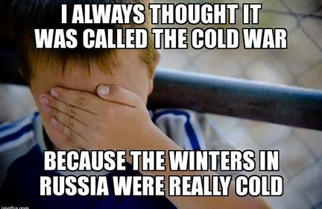  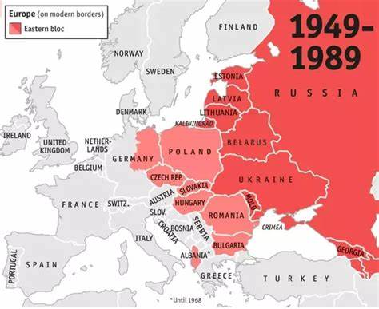  Eastern Bloc | - What two nations emerged as Super Powers after WWII?  - What did the Cold War set the framework for?  - What were two major changes provoked by WWII?  a.  b.  - Why were most European colonies abandoned?  a.  b.  - How was France forced out of Vietnam?  - Why did Britain and France attack Egypt?  - What countries made up the Eastern Bloc?  a.  b.  c.  d.  e.  - What did all of the countries of the Eastern Block have in Common?  - What was the “Iron Curtain”?  - What was the Marshall Plan designed to do?  - What countries occupied Germany?  a.  b.  c.  d.  - What was NATO?  - What did the Communist nations create as a reaction to NATO?  - What areas outside of Europe did the Cold War effect?  a.  b.  c.
The Resurgence of the West  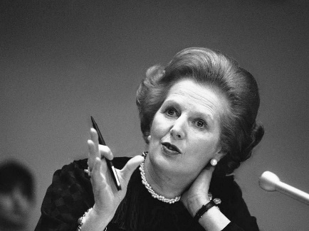  The “Iron Lady” Margaret Thatcher  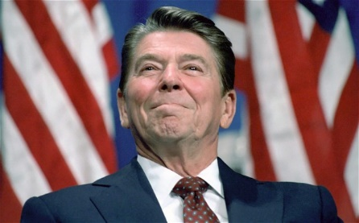  Ronald Reagan  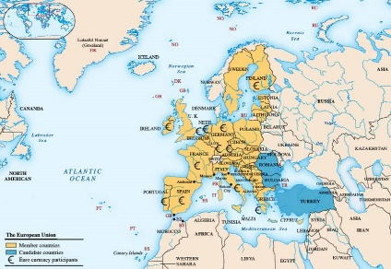  European Union | - What type of governments did Portugal and Spain adopt?  - Programs were introduced to reduce the economic inequality in Europe what were these programs called?  - What was used to add welfare programs in the US?  - What was a technocrat?  - What did the Civil Rights movement in the US attack?  - What type of rights did the Feminist movement focus on?  - What did the Green Movement focus on?  - Who was the leader of the British Conservative Party and longest running Prime Minister?  - What was the common currency used in the European Union?  - What happened to immigration in the US and Western Europe?  - What types of issues did the immigrants face in the West?  - What two government agencies did the US create in 1947?  a.  b.  - What was the “brain drain” of Europe?  - What is Pop Culture?  - What type of industry and weapons development did the Soviet Union focus on?

